

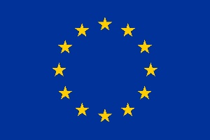

**European Research Council (ERC)**

**ERC Data Management Plan**

**Template**

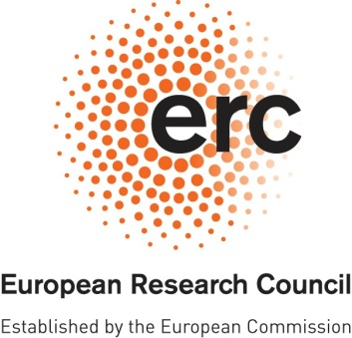**ERC OPEN RESEARCH**

**DATA MANAGEMENT PLAN (DMP)**

# 

|  |  |
| --- | --- |
| **Project Acronym** | **Project Number** |
| HICARE | 101113441 |

***Template for the ERC Open Research Data Management Plan (DMP). The following sections should describe how you plan to make the project data Findable, Accessible, Interoperable and Reusable (FAIR). Each of the following five issues should be addressed with a level of detail appropriate to the project.***

|  |
| --- |
| **SUMMARY** *(dataset[1] reference and name; origin and expected size of the data generated/collected; data types and formats)* |
| **EXP Experimental measurements** – Collected from hybrid C-arm scanner – 100 GB – Raw image data (non-human), stored in a standard format (DICOM) to ensure interoperability and alignment with FAIR principles.  **SIM Simulation measurements** – From simulations – 1 TB – Raw image data (non-human), stored in a standard format (DICOM) to ensure interoperability and alignment with FAIR principles. |

|  |
| --- |
| **1. MAKING DATA FINDABLE** *(dataset description: metadata, persistent and unique identifiers e.g., DOI)* |
| All experimental (EXP) and simulation (SIM) datasets will be organized with descriptive filenames that clearly indicate their contents, such as simulation configurations or experimental conditions. Basic metadata will be provided for each dataset, including a brief description of its purpose, key parameters, and relevant context, using a standardized metadata schema.  A simple inventory of the datasets will be maintained, summarizing their contents and how they relate to the project. This inventory is available on <https://ixsi.eu/ixsi-data/> which is already used for project related information and hence researchers are able to find it. This inventory ensures that the data remains findable and understandable without requiring extensive additional resources. |

|  |
| --- |
| **2. MAKING DATA OPENLY ACCESSIBLE** *(which data will be made openly available and if some datasets remain closed, the reasons for not giving access; where the data and associated metadata, documentation and code are deposited (repository?); how the data can be accessed (are relevant software tools/methods provided?)* |
| The EXP and SIM datasets will be made available to other researchers upon request, along with basic documentation explaining their structure and usage. To minimize storage requirements and reduce environmental impact, data will not be made openly available by default. If certain datasets cannot be shared due to confidentiality, legal restrictions, or other factors, the reasons will be clearly communicated.  Software tools or scripts necessary to read and process the data will also be provided upon request, ensuring accessibility without requiring specialized tools. Researchers can request access to the data or associated materials by contacting the project team via email. Email contact details will be included in related publications or shared upon inquiry.  For long-term preservation, data will be stored in a secure internal repository, and further storage solutions will be evaluated based on future needs. |

|  |
| --- |
| **3. MAKING DATA INTEROPERABLE** *(which standard or field-specific data and metadata vocabularies and methods will be used)* |
| All EXP and SIM data related to medical imaging will be shared in the DICOM (Digital Imaging and Communications in Medicine) standard format, which is widely used and supported in the medical field. This ensures compatibility with standard medical imaging software and tools. The metadata for these datasets will adhere to standard DICOM metadata fields, such as patient IDs, image modalities, etc., where applicable.  For non-imaging data, commonly used formats such as CSV or JSON will be utilized to ensure ease of integration with other datasets. If specific metadata or additional documentation is needed to interpret the data, it will be provided upon request to ensure interoperability across research applications. |

|  |
| --- |
| **4. INCREASE DATA RE-USE** *(what data will remain re-usable and for how long, is embargo foreseen; how the data is licensed; data quality assurance procedures)* |
| All EXP and SIM data will remain available for re-use for the duration of the grant and will be retained for at least five years afterward to support potential future research. No embargo is foreseen, and data will be shared upon request.  The data will be provided under an open license (e.g., CC0 or CC BY) to simplify re-use. Usability will be ensured through regular quality checks during the project, including validation against expected outcomes and verification for completeness and accuracy. After the grant period, updates to data formats or software compatibility (e.g., adjustments for DICOM changes) will be implemented only if specifically requested by other researchers. |

|  |
| --- |
| **5. ALLOCATION OF RESOURCES and DATA SECURITY** *(estimated costs for making the project data open access and potential value of long-term data preservation; procedures for data backup and recovery; transfer of sensitive data and secure storage in repositories for long term preservation and curation)* |
| All data will be stored on local servers and internally shared storage systems, with daily automated backups managed by the Technical Cluster and Data Management departments of the University Medical Center Utrecht. These systems ensure reliable data recovery in case of hardware failure or accidental loss.  Sensitive data will be transferred securely using encrypted channels and stored in restricted-access directories to comply with privacy and security regulations. Long-term preservation is not considered critical, as the data can be regenerated when necessary, minimizing costs and environmental impact. However, a secure internal repository will be used for data storage and backup, and further long-term storage solutions will be considered if needed. No additional funding is allocated for long-term open access storage. |

**DISCLAIMER. Please note that the ERC Data Management Plan is not a part of the Ethics Review. It is the responsibility of the Principal Investigator to inform the ERCEA Ethics Team of any ethics issues/concerns regarding the collection, processing, sharing and storage of data in relation to the project.**

1. *Several datasets may be included into a single DMP.*